







**EKA University of Applied Sciences,**

**Alberta College, Sumy State University, Ferris State University, AMBIS University and Association of Latvian Economists**

**invite you to participate in the International Scientific Conference**

**EMERGING TRENDS IN ECONOMICS, CULTURE AND HUMANITIES (ETECH2025)**

**APRIL 23-24, 2025, RIGA, LATVIA**

**VENUE: EKA, Pernavas 62, Riga, Plenary session - TBA**

**TOPICS: EMERGING TRENDS IN**

* *Sustainability and circular economy*
* *Social entrepreneurship*
* *Macroeconomics, international economics, public economics and financial economics*
* *****Business administration, marketing and corporate finance*
* *Culture studies and international culture project management*
* *Creative industries, art and design*
* *Law*
* *ICT solutions for business, management and education*

**CONTACT INFORMATION**

Dr.oec. **Jevgenija Dehtjare**, Head of the Development of the EKA Scientific Institution

Phone: (+371) +371 22 541 338, e-mail: [jevgenija.dehtjare@eka.edu.lv](mailto:jevgenija.dehtjare@eka.edu.lv)

**IMPORTANT DATES**

|  |  |
| --- | --- |
| **Registration** (with a short abstract) | Up to **February 23, 2025** |
| **Payment of a conference fee** (standard fee EUR250) | Up to **March 15, 2025** |
| **Submission of a full paper** | Up to **March 15, 2025** |

|  |
| --- |
| **REGISTRATION** |

The participants should register with a short abstract (1500-2500 characters) via conference electronic registration system etech.eka.edu.lv **Abstract template** is available for uploading in the registration system.After the notification of the abstract acceptance participants can send a full paper to the address [jelena.titko@eka.edu.lv](mailto:jelena.titko@eka.edu.lv) **Paper template** is available in the registration system.

**PUBLICATION OPPORTUNITIES**

Journal „**Economics and Culture**” (ISSN: 2255-7563 / e-ISSN: 2256-0173). Indexed by **SCOPUS**, ERIH+ and other services. More information at <https://content.sciendo.com/view/journals/jec/jec-overview.xml>

Journal “**Business, Management and Economics Engineering**” (ISSN: 2669-2481 / eISSN: 2669-249X). Indexed by **SCOPUS**, Emerging Sources Citation Index(**Web of Science**), ERIH+ and others. More information at <http://bmee.vilniustech.lt> (APC is applied EUR 484)

Journal “**Marketing and Management of Innovations**” (ISSN: 2218-4511 / e-ISSN: 2227-6718). Indexed by Emerging Sources Citation Index (**Web of Science**) and others. More information at <http://mmi.fem.sumdu.edu.ua/>

Journal “**Virtual Economics**” (ISSN: 2657-4047). Indexed by **SCOPUS** and others. More information at <https://virtual-economics.eu/>

Journal “**Forum Scientiae Oeconomia**” (ISSN: 2300-5947). Indexed by **SCOPUS** and others. More information at <https://ojs.wsb.edu.pl/>

Journal “**Ekonomika**” (ISSN 2424-6166). Indexed ERIH+, **SCOPUS** and others. More information at <https://www.journals.vu.lt/ekonomika/>

“**Journal of Economics and Management**” (ISSN 1732-1948). Indexed ERIH+, **SCOPUS** and others. More information at <https://sciendo.com/journal/JEMUEKAT>

**CONFERENCE FEE**

|  |  |
| --- | --- |
| Standard fee till March 15, 2025* | **EUR 300** |
| Online participation** | **EUR 150** |
| Fee for accompanying person | **EUR 100** |

*Standard fee includes: attendance of conference sessions, certificate of presentation, conference materials, coffee breaks, lunch, welcome reception on April 23, 2025, Gala Dinner on April 24, 2025, and publication of the selected papers in etECH partner journals.

** Online fee includes: virtual attendance of conference session, certificate of presentation, and publication of the selected papers in etECH partner journals.

One author can submit maximum 1 paper.

If the paper is not accepted for publishing, the conference fee will not be refunded.

**Payment details:**

Beneficiary name: Ekonomikas un kulturas augstskola  
Beneficiary address: Pernavas 62, Riga, LV-1009, Latvia  
Beneficiary registration No: 40003402986  
Bank: Citadeles banka  
Bank SWIFT: PARXLV22

Beneficiary IBAN (account No): LV54PARX0000350971017

Payment details: etECH2025 participation fee – Name Surname

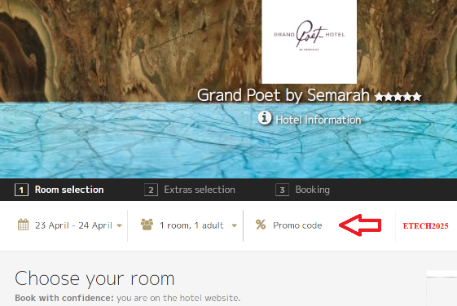**ACCOMODATION OFFERS**

Special prices for ETECH participants!

Use **ETECH2025** promo code!!!

**Grand Poet by Semarah hotels**:

Single room / Double room EUR 115/135 per night

Book online at <https://grandpoet.semarahhotels.com/en/>

**Metropole by Semarah hotels:**

Single room / Double room EUR 63/75 per night

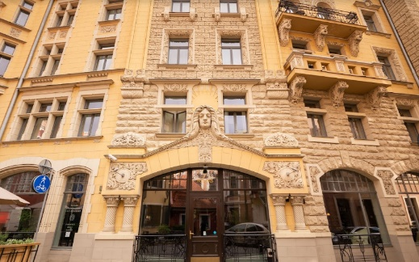Book online: <https://metropole.semarahhotels.com/>

**Neiburgs Hotel & Restaurant**:

Single room / Double room EUR 103/121 per night

Book via e-mail: [reservation@neiburgs.com](mailto:reservation@neiburgs.com)