Invitation to the urban workshop “Walking like a dog - understanding canine behaviour in the urban environment”

Dear Sir or Madam,
We warmly invite staff members and PhD students of the ZUL network universities, partners of the project AIM – Attracting International Minds. Lublin NAWA-EURAXESS Network to participate in the urban workshop from the series “Academic Walks with the Nature of Poland.”
Location: Lublin
Date: July 28, 2026
Instructors:
mgr inż. Kamila Kaszycka
About the workshop:
This interactive outdoor workshop aims to help participants understand how dogs perceive and experience urban environments.
During the guided walk, participants will learn about:
- interpreting canine body language,
- recognising communication signals and signs of stress,
- the importance of environmental exploration during walks and the factors that influence canine welfare in urban settings.
The workshop also covers the principles of responsible dog ownership, the characteristics of dog-friendly urban spaces, and examples of good practices from different countries. Participants will discuss how cities can better support the welfare of companion animals.
Workshop programme:
16:00 – Welcome, introduction to the workshop, and safety information.
16:10 – How dogs perceive the urban environment: canine senses, communication, and behaviour.
16:30 – Guided walk: observing urban spaces from a dog's perspective.
16:55 – Interactive activities: interpreting canine body language, recognising stress and calming signals, and discussing the most common challenges dogs face in urban environments.
17:20 – What makes a city dog-friendly? Discussion on urban design, responsible dog ownership, and examples of good practices from different countries.
17:40 – Questions, discussion, and workshop summary.

Registration:
We invite academic staff employed at one of the partner universities listed below, as well as doctoral students enrolled in doctoral schools operating at these universities, to participate in the workshops.
- Maria Curie-Skłodowska University
- University of Life Sciences in Lublin
- John Paul II Catholic University of Lublin
- Lublin University of Technology
- Medical University of Lublin
If you would like to participate in the workshop, please complete the registration form by 20th July 2026. The aim of the workshop is to combine natural sciences popularisation with intercultural integration. The number of places is limited to approximately 20 participants, including at least 10 international participants, and will be allocated according to the order of submission.
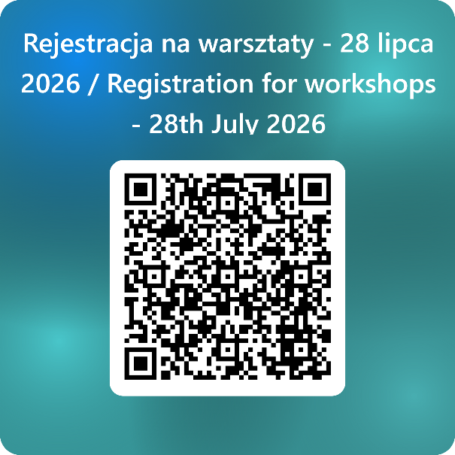
The organisers will ensure a balanced selection process, allowing representation from all partner institutions.
Participants registering for the workshops are requested to familiarize themselves with the information clause for workshop participants, as well as with the information concerning the processing of personal data of contractors and representatives of contractors of the Polish National Agency for Academic Exchange, the information provided by the minister responsible for regional development, and the information provided by the National Centre for Research and Development.

Programme NAWA-Euraxess network is financed from the European Funds for Social Development 2021-2027 (EFSD), under the NAWA project entitled “Support for higher education and research institutions in assisting foreign nationals and Polish citizens going abroad”, no FERS.01.05.IP.08-0003/24.

