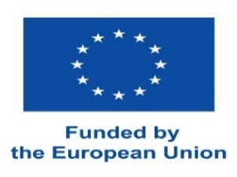 | Erasmus+ Programme  STAFF MOBILITY FOR TEACHING

CONFIRMATION

STAFF MEMBER
Name and surname

SENDING INSTITUTION
Name of sending institution | Lublin University of Technology
Erasmus ID code | PL LUBLIN03

RECEIVING INSTITUTION
Name of receiving institution
Erasmus ID code

This is to certify that the above mentioned person has taught ______8______ hours under the Erasmus+
Number of hours taught

programme at our institution from ............./.............../............. to ............./............/................ of the academic year 202....../202.......

Date: _______________________________

Signed: _____________________________

Stamp: _____________________________

